Problem 4

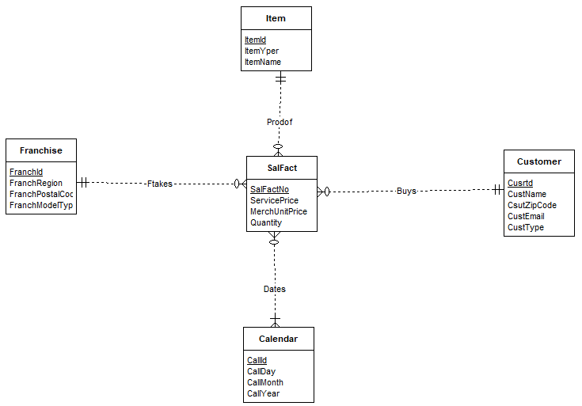

The above star schema, provides a solution for the given datawarehouse. The Customer entity takes in values for the fact table SalFact through Buys. The merchandise sales and services sales are tracked with multiple values through Prodof relationship. This total sale value is product of Quantity and MerchUnitPrice. Calender Entity tracks all the dates for Service Purchases, Merchandise Purchases and Customer Prices.